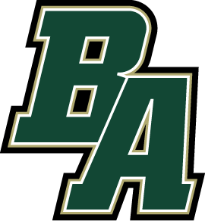

BULLOCH ACADEMY
2023 MIDDLE SCHOOL WRESTLING

DAY | DATE | EVENT | LOCATION | TIME
Sat | Nov 18 | Middle School Battle at Bryan Duels | Bryan County HS  Pembroke, GA | 8:30
Thur | Nov 30 | Toombs Fight Night | Toombs County HS  Lyons, GA | 4:00
Thurs | Dec 7 | Dual vs Statesboro  (Youth Night) | Home  Legacy Gym | 7:00
Tue | Dec 12 | Dual vs Pinewood | Home  Legacy Gym | 5:00
Wed | Dec 13 | Duals at Bryan County | Bryan County HS  Pembroke, GA | 4:00
Fri | Dec 15 | Bulldog Brawl Duals | Toombs County HS  Lyons, GA | 3:30
Fri | Jan 5 | MS Cavalier Clash | Mount de Sales  Macon, GA | 3:30
Sat | Jan 13 | GIAA MS State Tournament | Brokstone School  Columbus, GA | TBD

Head of School: Leisa Houghton | Interim Athletic Director: Tripp Turley
Head Coach: Trey Walker

Updated 11/10/2023

HOME OF THE GATORS
873 Westside Road | Statesboro, Georgia 30458 | Phone: (912) 764-6297
www.bullochacademy.com

